

What do you want to see changed? What would make it perfect? What do you want to improve?

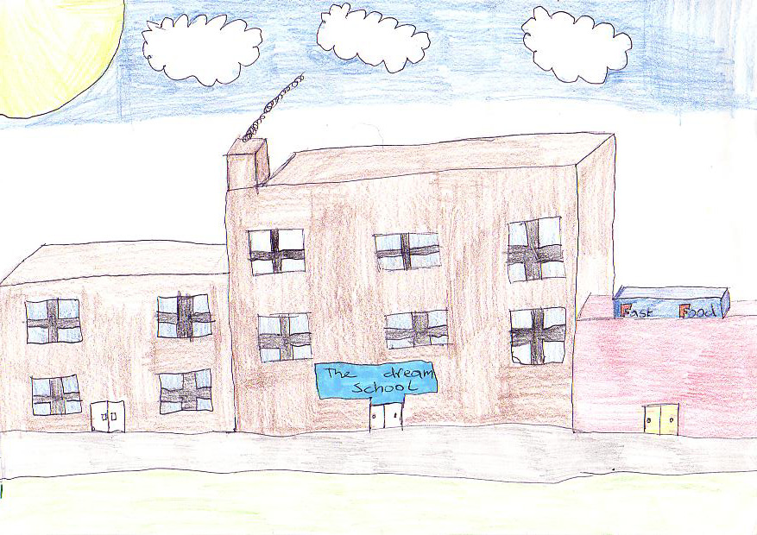
All Sylmar Community Members – Please Join Us!

Sylmar High School’s
Dream School Visioning Meeting
Tuesday, July 12th
1:00 – 2:30 pm
Room 50

Our dreams will become reality if we all work together!

